AKTID: two new cutting-edge sorting lines
for Braley

Braley and AKTID, two companies based respectively in Aveyron and Savoie, have been partners for 20 years. In a further demonstration of confidence, Braley has commissioned AKTID to build its new sorting lines — one dedicated to processing wood and green waste, the other to sorting industrial waste, construction and demolition waste, and bulky items from waste-collection centres.

Braley’s trademark innovation is once again in the spotlight. The facility incorporates cutting-edge equipment, including dual-arm robots used to recover heavy components.

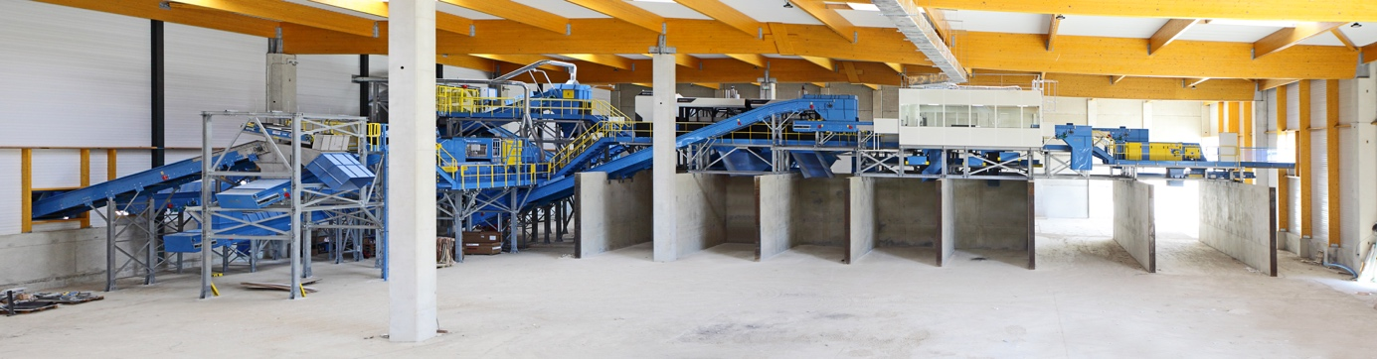

↑ Braley: industrial waste processing line

Many companies, if two fires had reduced a large part of their buildings to ashes, would have simply closed down. But that would be to overlook the drive and the resilience of the Braley family and their team. Not only did they decide to rebuild, they also injected more technology and greater efficiency!

To do so, they chose to rely on their long-standing partner, the AKTID company, to design and build their two sorting lines in Bozouls.

The first line, which AKTID commissioned in 2019, is dedicated to processing wood and characterised by its multipurpose functionality. It alternately processes B-grade lumber and green-waste composting rejects, and is sized to process between 45,000 and 90,000 tonnes of matter per year. It is designed to allow the grade of the outgoing flow to be adjusted to meet market requirements.

The second line, commissioned in early summer, is sized to sort 60,000 t/year of multi-flow waste composed of industrial waste, construction and demolition waste, and bulky items from waste-collection centres. This plant, which is packed with automation and robotisation, is currently one of the most technologically-advanced facilities in Europe.
Among the flagship features of this new mechanised process, AKTID is introducing ZenRobotics dual-arm robots to work on the ultra-heavy portion of the facility. Using artificial intelligence, they simultaneously and very rapidly sort six different products by shape and composition. Positioned just before the control cabin, they significantly boost the sorting line’s efficiency and flexibility. They spare the operators from having to move heavy loads and they drastically reduce the need for quality control, since the line can even operate on its own, depending on the types of incoming flows.
As for the majority of AKTID’s industrial waste-sorting facilities, the upstream flow is prepared by two vibratory screens made by the US-based company Action, of which AKTID is the sole distributor in Europe. “We fell in love with the Action screens on a trip to the USA organised by AKTID”, says Ludovic Braley, co-manager of the company of the same name. He went on: “The Action screens are extremely hard-wearing and, to our knowledge, no other screens are as effective”. “They maintain a steady flow to the equipment positioned further along the line, ensuring optimal performance for the whole process,” explains Patrick Flocher, sales manager of private projects at AKTID. The primary screen, a Taperslot®, is designed to separate out heavy, voluminous or complex materials by size. The secondary screen, the Vibrasnap®, uses the Flip-Flow technology to separate out fine materials by bouncing the material on a perforated polyurethane sheet.
“After only a few weeks in operation, the whole process has attained the expected performance levels. It is capable of processing very diverse flows while guaranteeing a very high rate of recovery,” enthused Ludovic Braley.

This new sorting centre enables Braley to increase the volumes of waste processed and, most importantly, to significantly improve their recovery rate. The latter may be even further improved in the future, given that the facility is designed to produce a flow of light waste that can be processed into refuse-derived fuel (RDF): one of the development and innovation ideas under consideration by the Braley company.

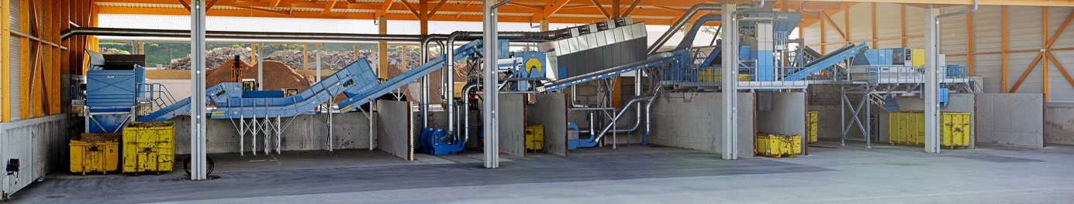

↑ Braley: wood processing line

About AKTID
AKTID is a French SME specialised in designing and building turnkey sorting and processing facilities for solid waste derived from household waste, industrial waste and construction waste. It is also an expert in building units that produce solid refuse-derived fuels.
The turnkey solutions developed by AKTID come in all sizes and range from the simplest to the most complex. They are intended for each of the three market segments: independent recyclers, large groups and local authorities.

With around 150 facilities built over the past 25 years, Aktid has, over the years, become the French standard-setter in sorting centres and is now looking to capitalise on its national success to guide and support its corporate customers abroad.

Learn more about AKTID: Press kit
Press Contact
Email: presse@aktid.fr
Tel: (+33) 04 79 71 85 10

