The Cassous Group selects AKTID to build its construction-waste sorting line

AKTID is set to build the Nouvelle-Aquitaine region’s first mechanised sorting facility for construction waste. The product of close collaboration between the turnkey contractor and the Cassous Group, the new sorting centre will make it possible to recycle or reuse over 80% of the waste.

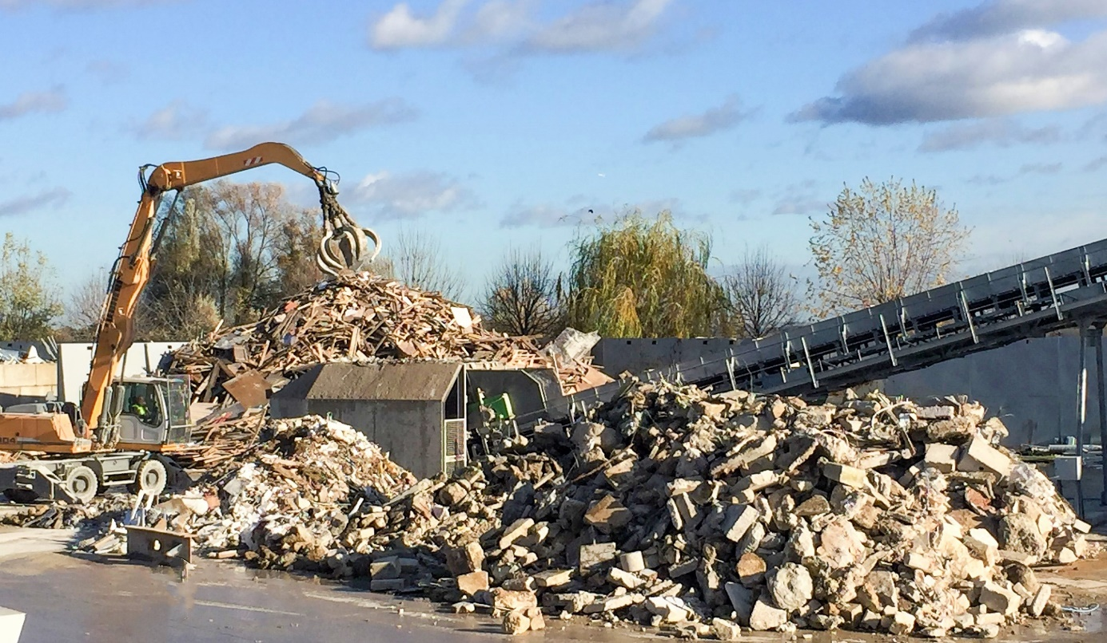
© AKTID - Construction-waste sorting centre

Chambéry, [date] July 2021 — The Cassous Group, which is based in the Nouvelle-Aquitaine region and specialises in construction work and services in the building and public works sector, is radically expanding its involvement in sectors related to the environment. Today, the Aquitain Group has decided to expand its waste-sorting and recovery operations by building its first sorting centre for construction waste. For the design/build phase of this facility, the Cassous Group, in tandem with its two partners, the Garandeau and Brangeon Groups, has chosen to draw on the expertise and guidance of the Savoie-based turnkey contractor, AKTID.

The project aims to build the Nouvelle-Aquitaine region’s first mechanised sorting facility for construction waste, with a view to substantially reducing the volumes of buried waste. The new sorting centre, based in Mérignac, near Bordeaux, will help optimise material recovery rates, pushing them up from a mere 15% currently in Nouvelle-Aquitaine to a recovery rate of over 80%. “The technology used on this line will make it possible to sort inert items (mineral waste) by granulometry (particle size) and ‘clean’ them. The product obtained at the end of the sorting process will be clean and directly usable as quarry fill. For the rest, the process extracts the other recoverable materials (such as metals and plastics) and ultimately leaves only the non-recoverable waste as rejects,” explains Patrick Folcher, AKTID’s Sales Manager.

The construction of this facility is the outcome of long-standing, close collaboration between the Cassous and Garandeau groups on one hand and the turnkey contractor AKTID.

“Since the project’s inception three years ago, AKTID has played a fully-fledged guidance and support role. Visiting several AKTID-built facilities and producing a precise, detailed description of our incoming flows helped us orient our technical choices and design an optimised process,” explains Philippe Durand, Vice-President of the Cassous Group.

Work on assembling the sorting line will begin this autumn, with plans to commission the line in the first quarter of 2022.

About AKTID
AKTID is a French SME specialised in designing and building turnkey sorting and processing facilities for solid waste derived from household waste, industrial waste and construction waste. It is also an expert in building units that produce solid refuse-derived fuels.
The turnkey solutions developed by AKTID come in all sizes and range from the simplest to the most complex. They are intended for each of the three market segments: independent recyclers, large groups and local authorities.

With around 150 facilities built over the past 25 years, Aktid has, over the years, become the French standard-setter in sorting centres and is now looking to capitalise on its national success to guide and support its corporate customers abroad.

Learn more about AKTID: Press kit
Press Contact
Email: presse@aktid.fr
Tel: (+33) 04 79 71 85 10

