At Pollutec, AKTID unveils ABI, the first performance analysis and optimisation software designed specifically for waste-sorting centres

ABI is something of a revolution in sorting-centre management: it boosts line availability, lowers operating costs, improves production quality and brings operating teams greater peace of mind.

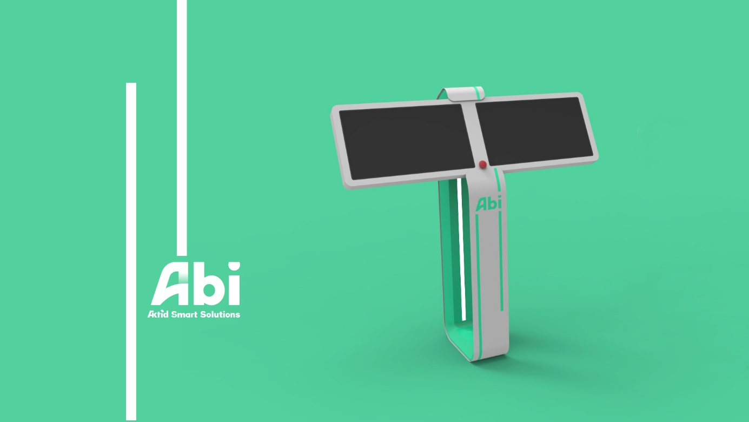

AKTID, the leading French design-build player in the waste-sorting sector, will present its range of AKTID Smart Solutions, and in particular its ABI software for analysing and optimising the performance of waste-sorting facilities, at the Pollutec show (12 to 15 October 2021 at Lyon Eurexpo, Stand 2-K100).

ABI – Aktid Business Intelligence – is the fruit of five years of Research and Development. The aim was to develop a simple, intuitive tool to control and supervise the sorting line, capable of analysing the incoming data and becoming a fully-fledged decision aid. It is this last feature that sets ABI above the existing solutions.

ABI is a data-processing system based on a Manufacturing Executive System (MES) that collects all real-time data from the equipment and sensors, and uses it to more efficiently run and manage production. Based on this solution, the AKTID team then adapted the programs and developed the interface to factor in the specific production features of waste-sorting facilities. “To achieve the best possible result and a solution that was truly tailored to the operators’ needs, we had to include our customers in the design process,” explained Frédéric MILIN, Head of AKTID’s innovation department. The team accordingly spent many months going all over its customers’ facilities to analyse the issues facing each potential user, identify their priorities in terms of operational management and note the specific features of each.

“Our tool was not intended to be a mere supervision tool, but instead a fully-fledged data-analysis tool capable of handling predictive maintenance. In addition to analysing the sorting line’s performance in real time, ABI alerts users to the problems ahead. Important information is instantly displayed, along with an explanation of the current or emerging problem and instructions for dealing with it. This makes it possible to considerably reduce line stoppages. Faults and problems are ranked by urgency to guide the staff as they take corrective action. Moreover, each stoppage is described in full. This makes it easy for the operational manager to analyse the performance of each item of equipment and identify ways to optimise them,” says Frédéric MILIN.

At the same time, AKTID has developed a mobile app that staff can use to view performance data and alerts on the go. It also allows operators to describe line stoppages or record faults with their phone and add photos to illustrate their remarks. This function is a smooth and efficient way of communicating information between teams and ensuring proper management and prioritisation of the problems to be addressed.

Since 2019, AKTID has been testing ABI at five sites simultaneously: three selective-collection waste-processing sites and two facilities for industrial and construction waste. The feedback has been used to refine the interface and is helping the AKTID team develop new modules.

“The feedback today is unanimous: the teams are less stressed and more efficient. The sorting facility’s performance is far more effectively managed and, more importantly, improved,” concludes Frédéric MILIN.

About AKTID
AKTID is a French SME that designs and builds turnkey sorting and processing facilities for solid waste such as household waste, industrial waste, construction waste and plastic recycling. AKTID also designs production plants for solid refuse-derived fuel (RDF).
The turnkey solutions developed by AKTID come in all sizes and range from the simplest to the most complex.

To guide and support its customers’ industrial development, AKTID recently developed the “AKTID Smart Solutions” product range. These products are grounded on a combination of insight, automation and analysis systems. They are designed to automate and more effectively steer all or part of our customers’ sorting facilities.
The Smart Packing module, for example, fully automates the packing of the sorted materials; Smart Regulation adjusts its facilities’ operation to its supply load; ABI steers the facility’s overall performance, etc.

With around 150 facilities built since 1995, Aktid has, over the years, become the French standard-setter in sorting centres and is now looking to capitalise on its national success to guide and support its corporate customers abroad.

Learn more about AKTID: Press kit

AKTID AT POLLUTEC

12-15 October

Lyon – Eurexpo

Hall 2 – Stand K10

Press Contact
Email: presse@aktid.fr
Tel: (+33) 04 79 71 85 10

