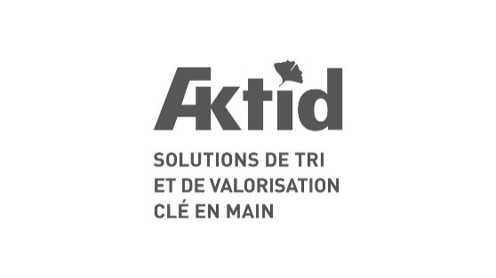 |  | 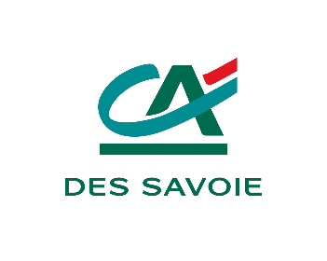

July 12th, 2023

Press release

French leader in waste sorting facilities, Aktid wants to accelerate its international growth by opening its capital

French private equity fund Initiative & Finance "Tomorrow" has just acquired a significant stake in Aktid, accompanied by Crédit Agricole des Savoie, historical partner of the Chambéry based company. Aktid, of which Pierre-André Payerne remains the majority shareholder, has now all the cards in hand to implement its international development projects.

French company leader in the design and construction of non-hazardous solid waste sorting and recovery facilities, Aktid has the wind in its sails as evidenced by its turnover which has doubled in one year, from 40 to 80 million euros. The workforce has also increased significantly with the creation of about thirty jobs last year, to meet the expectations of public and private customers. This dynamic will be able to continue internationally thanks to the support of Initiative & Finance's "Tomorrow" fund and Crédit Agricole des Savoie. This growth strategy should be based on both a targeted external growth policy and organic growth in territories offering attractive fundamentals and prospects.

Partner of Aktid, Initiative & Finance "Tomorrow" intends to accompany the top management project and support its development thanks to its financial expertise and the deep experience of its team in supporting SMEs towards a change of scale internationally. Very committed to environmental issues, Initiative & Finance "Tomorrow" confirms the relevance of Aktid's project, which is positioned in a market considered as strategic. Waste management is a major focus of the environment and sustainable development that lies at the crossroads of economic, political, and social concerns. The values shared by all partners make this operation a true pact of confidence for the future.

« Aktid comes to the end of a 10-year strategic cycle during which the Company and its teams have become immensely professional. We approach the next cycle of our development with enthusiasm and realism: the internationalization of the Company. We are pleased to be able to count on the support of Initiative & Finance "Tomorrow", and Crédit Agricole des Savoie, our historical banking partner, to expand our resources and aggregate our experiences in order to succeed in this new strategic step at the right pace. » summarizes Pierre-André Payerne, Aktid CEO.

“The arrival of Initiative & Finance "Tomorrow" within Aktid is a strategic choice consistent with our values. Strategic because we are convinced by the project, serene about growth prospects and united by a shared desire to build a more sustainable world. Coherent because this virtuous trajectory requires an international approach to be more influential and efficient tomorrow," says Caroline Pihan, Partner Midcap at Initiative & Finance.

Baudouin d’Hérouville, Partner and Head of Midcap at Initiative & Finance, adds : “Our investment in Aktid is the third operation of the "Tomorrow" Midcap buyout fund, which supports in private capital contexts the management teams of medium-sized companies putting the sustainability of their business model at the heart of the company's project. We are very pleased to support Pierre-André Payerne and his talented workforce in the implementation of their ambitious project.”

LIST OF PARTICIPANTS

Financial investors
- Initiative & Finance "Tomorrow" : Caroline Pihan, Baudouin d'Hérouville, François-Xavier Oliveau, Sacha Azuelos, Jean-Baptiste Bost)
- Crédit Agricole des Savoie : Jean-Yves Riowal, Christophe Cheminal
Financial investors' advisors
- Legal advisors: Weil, Gotshal & Manges (Frédéric Cazal, Henri Mazeau)
- Financing advisors (Géraldine Lezmi, Awen Carnot)
- Tax advisors: Weil, Gotshal & Manges (Edouard de Lamy, Axelle Trintignac)
- Strategic due diligence: Sia Partners (Charlotte de Lorgeril, Raphaël Barth, Mathieu Morel, Pauline Henry Sonnier)
- Financial due diligence: EY (Emmanuel Picard, Linh-Lan Pham)
- Environmental due diligence: Ethifinance (Bastien Guerrier, Basile Deveaux)
- Insurance due diligence: Finaxy (Deborah Hauchemaille)
Aktid and advisors
- Aktid: Pierre-André Payerne
- M&A advisors: Mazars (Matthieu Boyé, Matthieu Maquet, Alban de Liniers, Margaux Loeb)
- Legal and taxation advisors: Joffe & Associés (Christophe Joffe, Charlotte Viandaz, Clémence Bressolin, Clément Peillet), Goutagny avocats (Denis Dord, Benjamin Hübsch)
Bank financing
- Arranger: Crédit Agricole des Savoie (Marie Gatumel, Anael Charnay)
- Co-arranger: Arkea (Rémi Bruyelle)
- Participant: Caisse d'Epargne Rhône-Alpes (Beatrice Chabrand, Hugo Le Noblet)
- Legal advisor: De Pardieu Brocas Maffei (Sébastien Boullier de Branche)

Press contact:
Droit Devant - Cécile de Bentzmann - 06 03 18 97 73 - bentzmann@droitdevant.fr

About Aktid
Since the beginning of the activity in 1995 by Pierre-André Payerne, Aktid has established itself as a major player in the waste sorting industry. Specializing in the design and construction of turnkey facilities for sorting and recovering non-hazardous solid waste (household waste, waste from economic activities, building waste and plastic recycling), the company also stands out for its expertise in the manufacture of solid recovered fuels (SRF) and in the modernization of existing sorting centers.
Its solid foundations and significant experience acquired on the French market allow the company to calmly begin its international development and meet the challenges of the waste management sector.

A propos d’Initiative & Finance « Tomorrow »
Since its creation in 1984, Initiative & Finance has carried out nearly 350 growth and buyout capital transactions and has contributed to the emergence of many mid-sized companies. A former subsidiary of the Natixis group, the management team became independent at the end of 2010 through its own MBO and now manages nearly €650 million in capital on behalf of leading French and European institutional investors and family offices. The Midsize LBO fund "Tomorrow" invests in companies from various sectors that contribute to implementing solutions to the challenges identified by the Sustainable Development Goals as defined by the UN, with a particular focus on those related to solving environmental challenges. More information on www.initiative-finance.com

